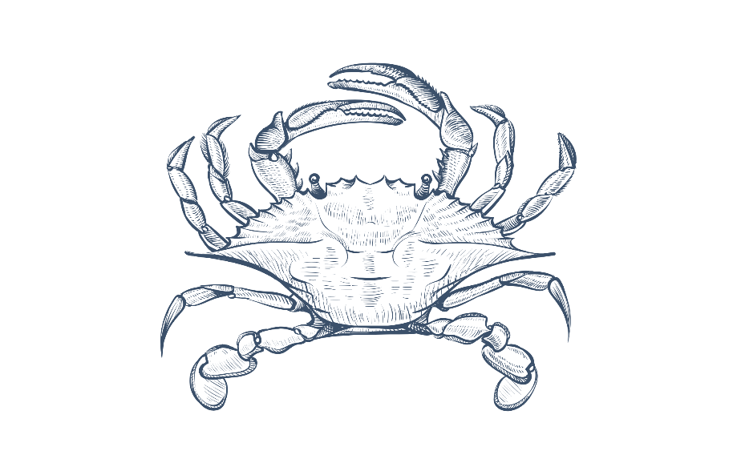
Tide – Dinner Menu
Lindisfarne Oysters – Served with your choice of dressing
Mignonette, Garlic & Parsley Butter or Poached in Champagne & Caviar (GF)
£3.50 Each – 3 for £10
Sourdough, Salted Butter £4
Lemon & Herb Marinated Olives £4 (GF,VG)
Starters
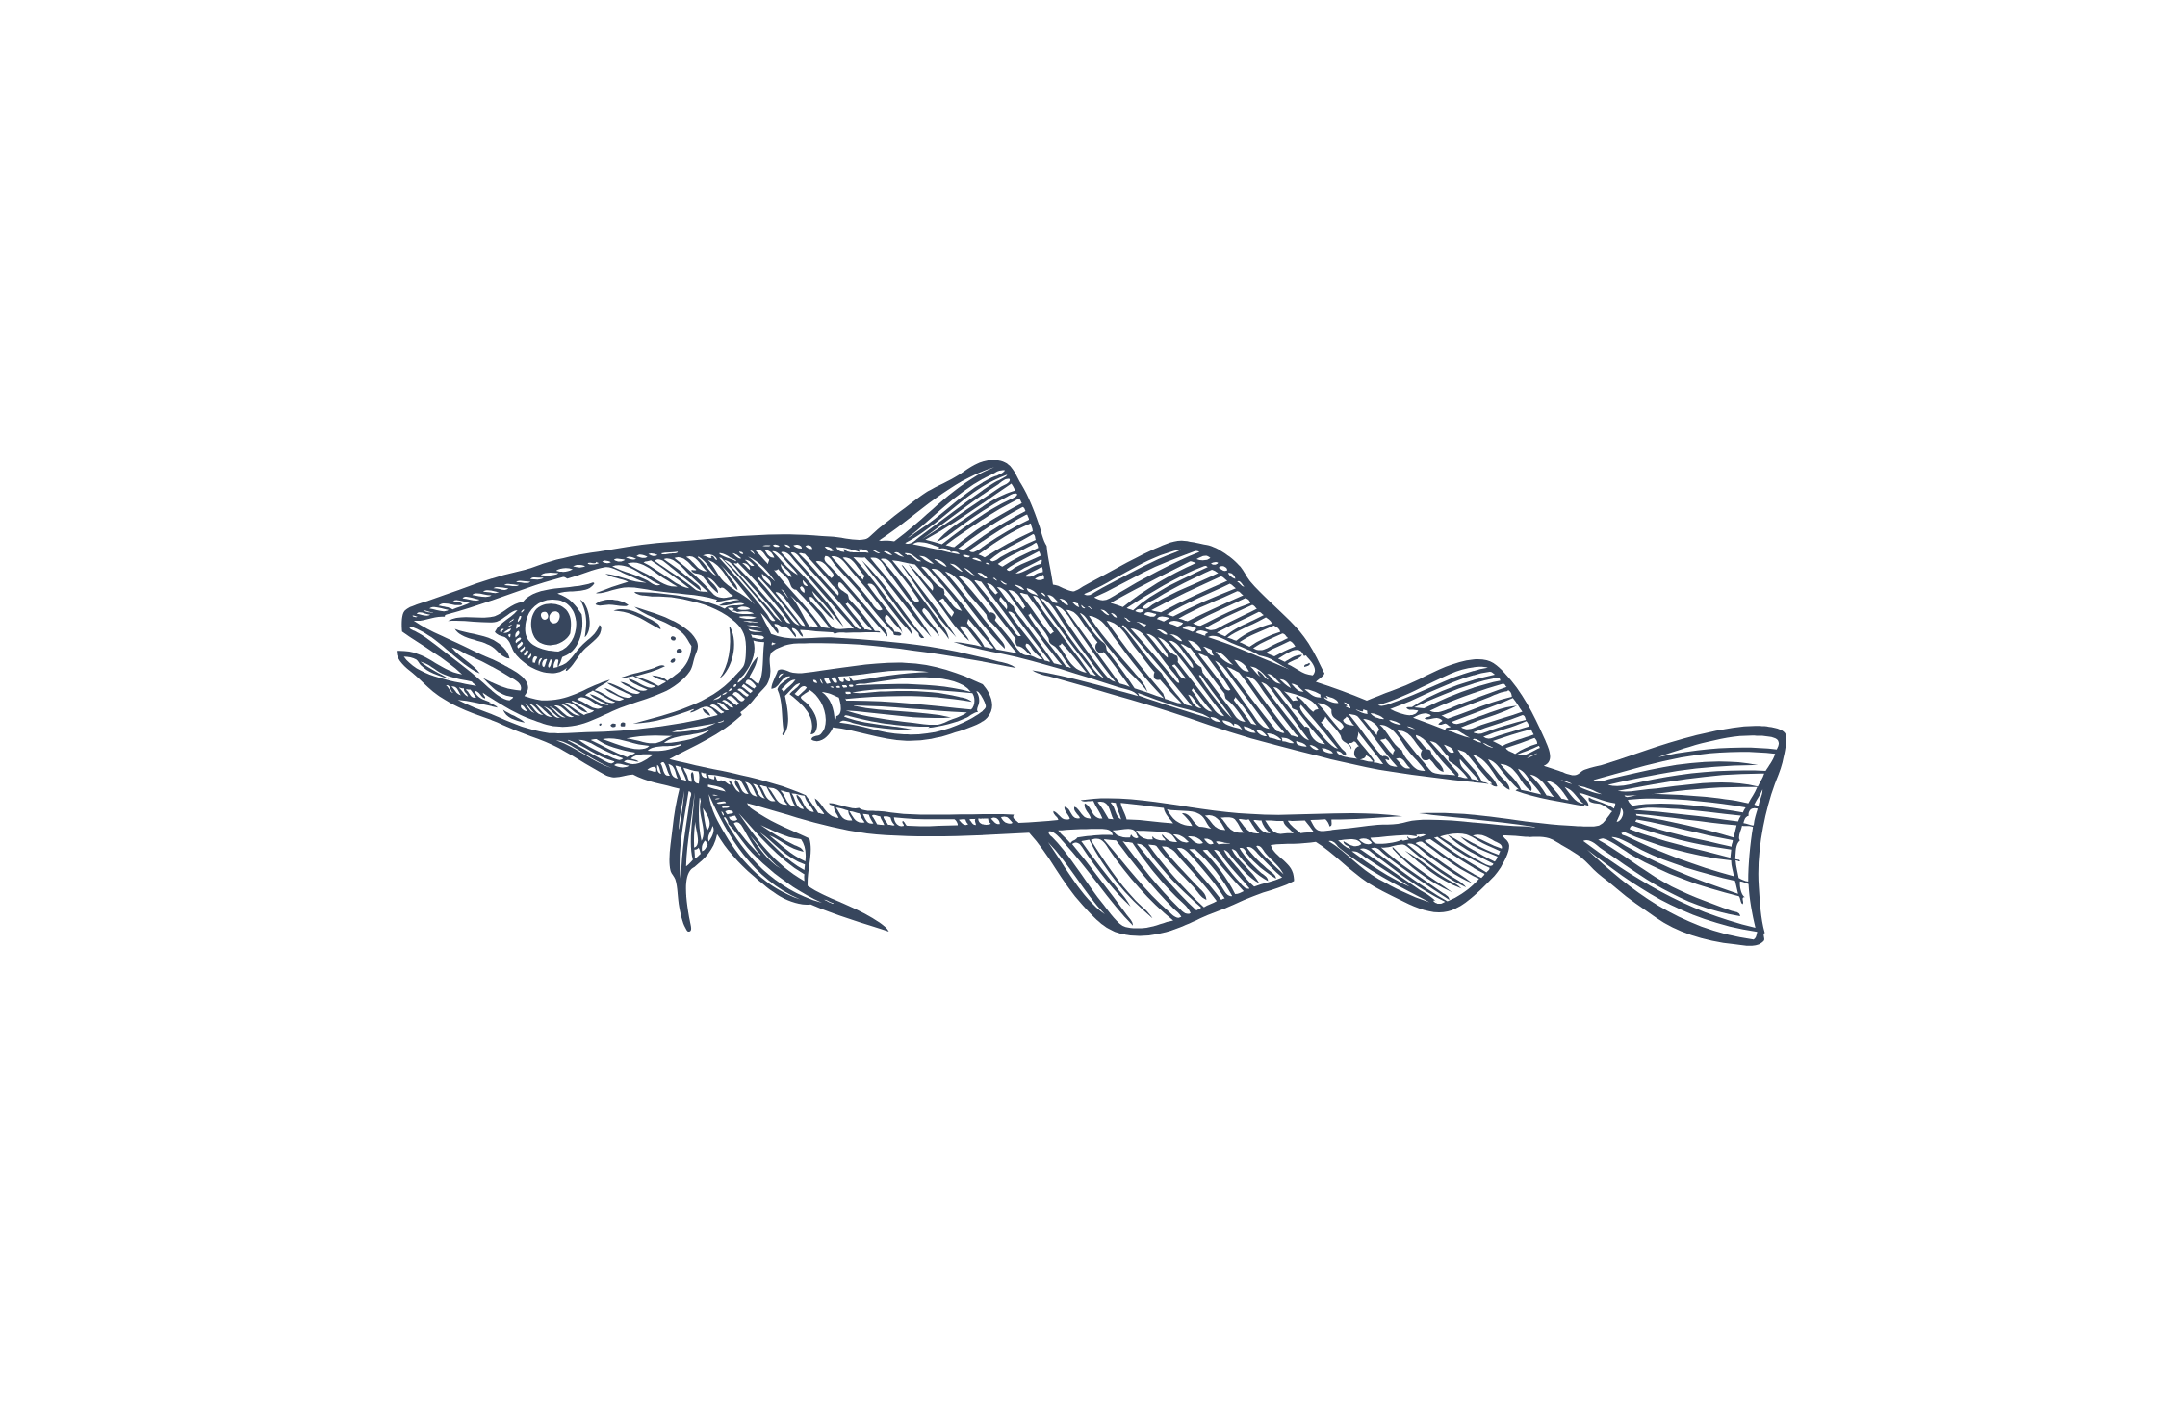
Pressed Ham Hock Terrine, Piccalilli, Toasted Sourdough, Herb Salad £9 (*GF)
Tide Prawn Cocktail, Iceberg lettuce, Tomato, Local Crab Spring Roll, Tempura Prawn £10
Classic Chunky Fish Soup, Mussels, King Prawns, Garlic Croutons, Rouille, Emmental Cheese £9 (*GF)
Salt & Pepper Squid, Siracha Mayonnaise, Chili & Spring Onion Salad £9
Burrata & Heritage Tomato Salad, Olive Oil, Basil, Honey, Balsamic Dressing £8 (*VG, GF)
Shetland Mussels, Garlic, Parsley, White Wine Cream, Toasted Sourdough £10 (*GF)
Mains
Roast Hake Fillet, Crab & Herb Crust, Shellfish Bisque, New Potatoes, Roast Fennel £20
Half Lobster, Served with Queen Scallops, King Prawns, & Finished with Garlic & Parsley Butter. Skin on Fries, Confit Tomato & Shallot Salad £30 (GF)
Slow cooked Pork Belly, Creamed Potato, Tenderstem Broccoli, Apple, Cider Jus £20 (GF)
Poached Whitby Smoked Haddock, Cheddar, Bacon & Spring Onion Mash, Poached Egg, Mustard Cream £19 (GF)
10oz Ribeye Steak, Roast Portobello Mushroom, Slow Cooked Tomato, Chips, Garlic & Parsley Butter, Watercress £28 (GF)
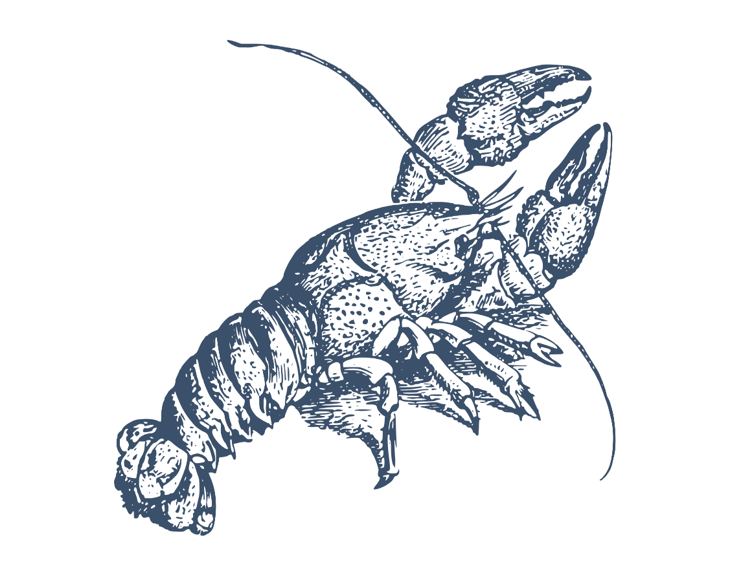
Wild Mushroom & Truffle Risotto, Parmesan, Herb Oil £16 (*GF)(*VG)
Sides
Beef Dripping Chips £4.95
Tender stem Broccoli, Sesame Dressing £4.95 (GF)(VG)
Skin on fries £4.95 (GF)
Skin on Fries, Parmesan & Truffle £5.25 (GF)

